1. Installation, Setup, and Configuration
System requirements
- Operating system: Windows 10/11, macOS 10.14+, or Linux
- Python: Version 3.8 or higher
- Disk space: at least 50MB of free space
- Memory: Minimum 4GB RAM

Step-by-Step Installation
Step 1: Install python
- Visit python.org
- Download Python 3.8 or higher for your operating system
- Run the installer with "Add Python to PATH" checked
- Verify installation by opening Command Prompt/Terminal and typing “python –version”
Step 2: Download the application
- Clone or download the application files from GitHub
- Create a project folder on your computer
- Place all application files in this folder
Step 3: Install dependencies
- Open Command Prompt/Terminal in your project folder
- Run the following command: “pip install -r requirements.txt”
(If no requirements file exists, the application uses only built-in Python libraries)
Step 4: Launch the application
- Navigate to your project folder in Command Prompt/Terminal
- Run the command: “python main.py”
- The application window should open automatically

2. Application Overview
Purpose
The student course manager is a desktop application that helps educational institutions manage student enrolments and course registrations efficiently. It provides a simple interface for administrators to handle student records, course catalogues, and enrolment related tasks.
Key Features
- Student management: add, view, update, and delete student records
- Course catalogue: manage course information and availability
- Registration system: enrol students in courses and track relationships
- Data export: export student and course data for reporting
- Theme customization: switch between light and dark modes for comfort

3. Step-by-Step Guides for Key Tasks
Task 1: Adding a new student
Step 1: Locate the student management section
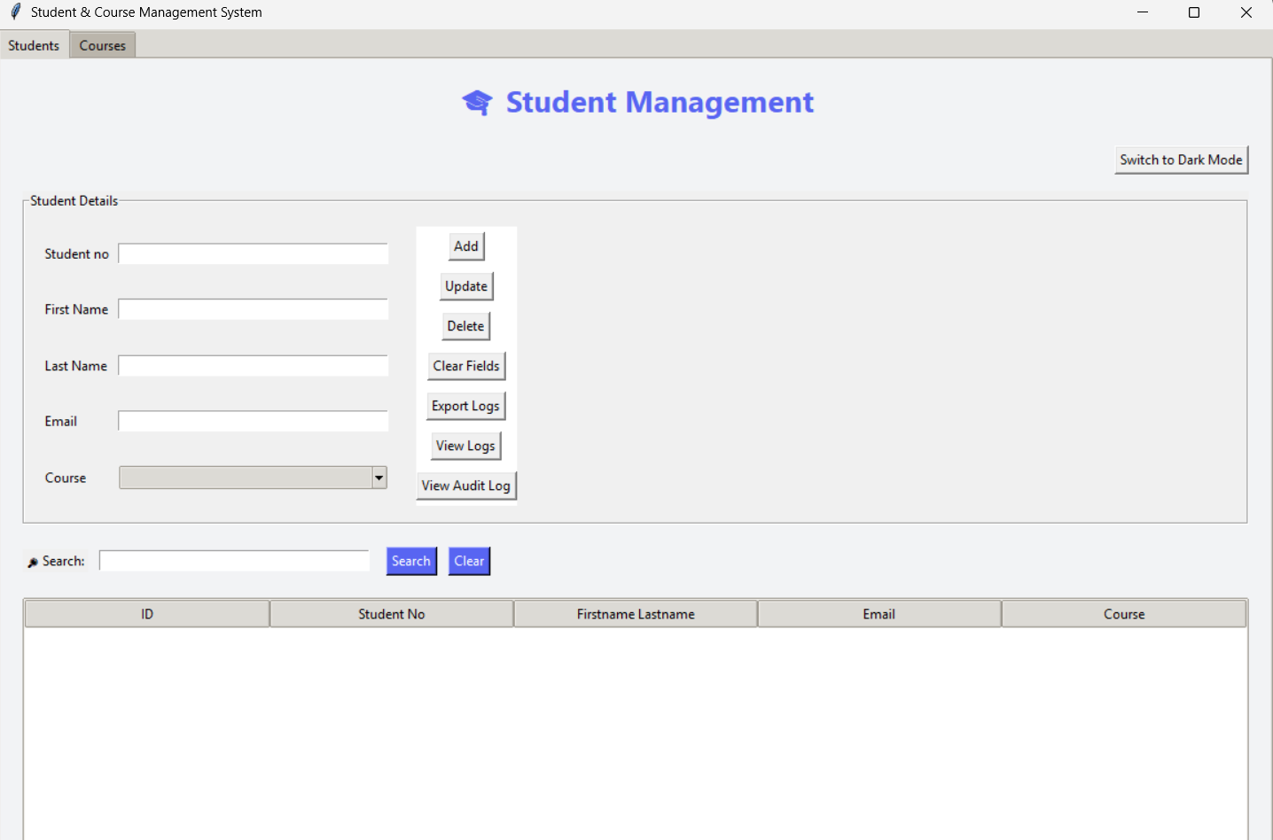

Step 2: Fill in student details
- Enter the student's first name
- Enter the student's last name
- Provide a valid email address
Step 3: Click the "Add Student" button
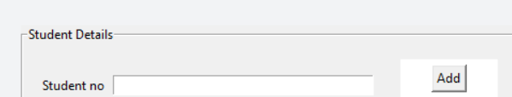
- The student will appear in the student list below
- A confirmation message will show if successful
Task 2: Creating a new course
Step 1: Find the course management section
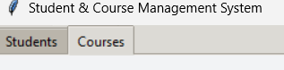

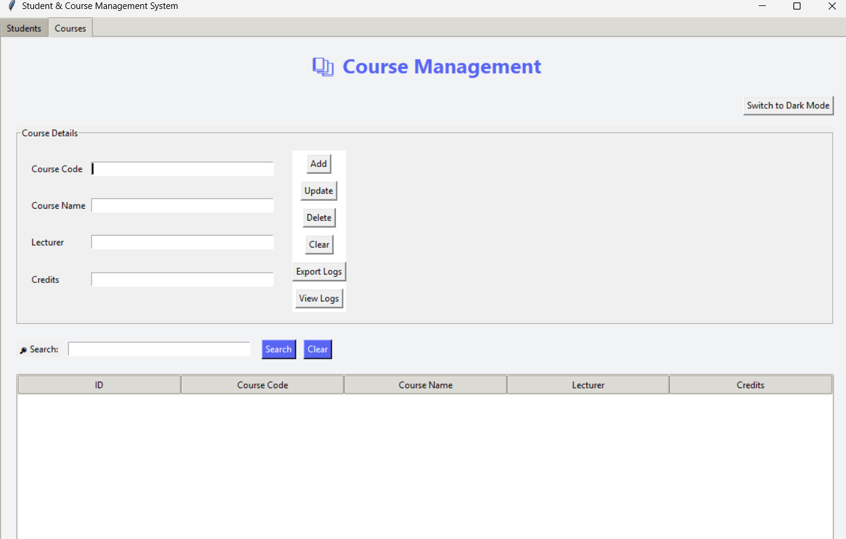
Step 2: Enter course information
- Input a unique course code (e.g., "COMP101")
- Provide the full course name (e.g., "SYSTEMMGMT I")
- Input the lecturer’s full name
- Set the credit value (typically 1-4)
Step 3: Click "Add Course"
- The course will be added to the course catalogue
- Verify the course appears in the course list
Task 3: Enrolling a student in a course
Step 1: Navigate to the registration section
Step 2: Select student and course
- Choose a student from the student dropdown
- Select a course from the course dropdown
Step 3: Click "Enrol"
- The system will create the enrolment relationship
- Check the enrolment list to confirm success
Task 4: Exporting Data
Step 1: Click the "Export Data" button in the top toolbar
Step 2: Choose export format
- The application typically exports to CSV format
Step 3: Select save location
- Choose where to save the exported file
- The file will contain all student and course data
Task 5: Changing application theme
Step 1: Click the theme toggle button
Step 2: The interface will instantly switch themes
- Light theme: Bright background, dark text
- Dark theme: Dark background, light text
Step 3: Your preference is saved automatically

Troubleshooting Tips and FAQs
Common Issues and Solutions
Problem: Application won't start
Solution:
- Verify Python is installed: python --version in Command Prompt
- Ensure all application files are in the same folder
- Check that you're running python main.py from the correct directory

Problem: "Module not found" error
Solution:
- Ensure you have all required files: main.py, db.py, model files, view files
- The application should use only Python standard libraries
- Re-download the application files if any are missing

Problem: Buttons don't respond
Solution:
- Check that all input fields have valid data
- Ensure required fields are not empty
- Try closing and reopening the application

Problem: Data not saving
Solution:
- The application uses an SQLite database (.db file)
- Verify the application has write permissions in its folder
- Check that the database file is not open in another program

Problem: Export function not working
Solution:
- Ensure you have written permissions in the chosen save location
- Check if the export file is already open in another program
- Verify the application has proper file system access

Frequently Asked Questions
Q: How many students/courses can I add?
A: The application can handle hundreds of records, but performance is best with under 1000 entries.

Q: Can I use this on multiple computers?
A: Yes, but the database is local to each installation. You'll need to transfer the database file or re-enter data on each computer.

Q: What happens if I delete a course with enrolled students?
A: The application should prevent this or handle it gracefully. Currently, it's recommended to drop all students before deleting a course.

Q: Is my data backed up?
A: The application creates an SQLite database file in the same folder. You should regularly back up this file manually.

Q: How do I update student information?
A: Select the student from the list, edit their information in the input fields, and click "Update Student" (if available) or delete and recreate the record.

Q: Can I customize the fields?
A: Field customization requires modifying the source code. Contact your system administrator for customizations.

